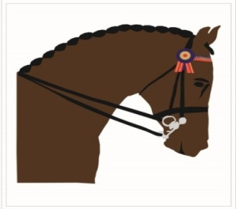
SHOWING ASSOCIATION OF SOUTH AFRICA
SASA

admin@showingsa.co.za www.showingsa.co.za

EXPRESSION OF INTEREST

TITLE OF EVENT: _________________________________________________

This application must be fully completed in respect of the above event, and must be submitted to relevant SASA Provincial Chairman or the SASA NTC by the 30th November or in the case of New Events (not previously on Calendar) at least 3 months before the Event date.

The SASA Provincial Committee will, in their sole discretion make a decision on whom to award the above event to, based on the most suitable application. The SASA Provincial Committee will not be bound to justify their decision.

In the case of a CN Status show this application must be submitted to SASA. The SASA National Technical Committee will, in their sole discretion make a decision on whom to award the above event to, based on the most suitable application. The SASA NTC will not be bound to justify their decision.

Show Holding Body

Details of other classes at the proposed Event | Dressage Driving Equitation Eventing Jumping Vaulting Other
Proposed Date | From |  | To
Proposed venue
Proposed Championship or Championships for Showing
Proposed Prize Money for Showing
Proposed Total Prize Money for Show (all Disciplines)
Sponsor
Has TV been arranged for main event |  |  |  | YES/NO

Motivation for the Application
…………………………………………………………………………………………………………………………………………………………………………………………………………………………………………………………………………………………………………………………………………………………………………………………………………………………………………………………………………………………………………………………………………………………………………………………………………………………………………………………………………………………………………………………………………………………………………

To be completed by the SASA Provincial Chairman and Provincial Committee
We confirm that we are satisfied that the information of this Expression of Interest is correct and that the Event will conform to the standards for this type of event as laid down in the General Regulations and the relevant Discipline Rules of SASA. We further confirm that in our opinion the venue and infrastructure is of the required standard for an event of this stature. We have notified the Organising committee of their financial responsibilities and we recommend that the Event applied for on the dates set out above be approved.

For Provincial Chairman and Provincial Committee:

_______________________________________ Date _________________

APPROVED BY SASA  DATE: | NOT APPROVED BY SASA  Date:

