SHOWING 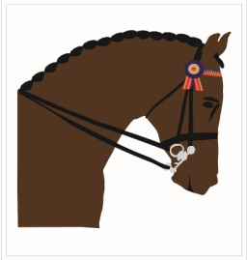

PROVINCIAL BODY TEAM NOMINATION AND FINAL SELECTION

Province |  | Year |  | ChallengeTeam
Championship | Adult | Junior |  | Pony  Rider
Venue

Provincial Showing Committees may nominate 5/6 riders and 6 horses.
. Please enter the full first and last names.

Team Manager

Rider’s Name
1
2
3
4
5
6

 | Horse’s Name | Final Selected  in Riding Order
1
2
3
4
5
6

Please place an “R” against the names of the reserve riders and horses if applicable. If no reserve is nominated and a team has to drop a rider/horse it will not be allowed to nominate any other riders/horses.

For National Association ___________________ ______________________Date __________________

